**COLLEGE OF COMPUTING, INFORMATICS AND MEDIA**

**UNIVERSITI TEKNOLOGI MARA,**

**MERBOK, KEDAH**

**DIPLOMA IN LIBRARY INFORMATIC**

**(CDIM144)**

**PROGRAMMING FOR LIBRARIES (IML208)**

**INDIVIDUAL ASSIGNMENT: STUDENT TUITION REGISTRATION**

**PREPARED BY**

**ATHIRAH MAISARA BINTI MOHD NIZAM (2022449416)**

**CLASS: KCDIM1443E**

**PREPARED FOR:**

**SIR AIRUL SHAZWAN BIN NORSHAHIMI**

**SUBMISSION DATE: 4TH JANUARY 2024**

**INDIVIDUAL ASSIGNMENT: STUDENT TUITION REGISTRATION**

**BY**

**ATHIRAH MAISARA BINTI MOHD NIZAM**

**(2022449416)**

**COLLEGE OF COMPUTING, INFORMATICS AND MEDIA**

**UNIVERSITI TEKNOLOGI MARA**

**MERBOK, KEDAH**

**4TH JANUARY 2024**

**ACKNOWLEDGEMENT**

ASSALAMUALAIKUM W.B.T

First and foremost, praises and thanks to Allah SWT, for His showers of blessings throughout my assignment to complete until the end.

I would like to express my special thanks of gratitude to Sir Airul Shazwan Bin Norshahmi who gave me the golden opportunity to do this wonderful individual assignment on the topic tuition subject registration, which also helped me in doing a lot of research and I came to know about so many stuffs I am thankful to him.

Lastly, I would like to thanks to my parents and my beloved friends for the support and the guidance. I am extremely grateful for them who helped me a lot in gathering different information and guide me from time to time in making this individual assignment even though they are busy with their own stuff. Thank you, again, for everyone that willing to cooperate to complete this assignment.

**TABLE OF CONTENT**

|  |  |
| --- | --- |
| **CONTENT** | **PAGE NUMBER** |
| ACKNOWLEDGEMENT | **i** |
| 1.0 Introduction | **1** |
| 2.0 Flowchart | **2** |
| 3.0 Code snapshot | **3-4** |
| 4.0 Gui snapshot | **5** |
| 5.0 Database snapshot | **6** |

1. **Introduction**

The topic that I choose for this assignment is student subject registration. The main reason I choose this topic is because student get to register subject that they want, and the system will automatically calculate the price of each subject that the students choose. This could make it easier for every parent to avoid worrying about overpayments to the tuition centre. The Python code supplied demonstrates a simple student registration system with a graphical user interface (GUI) built with the Tkinter package. Students can use this application to enter personal information, choose subjects of interest, and agree to terms and conditions. It also includes a registration button, which initiates data gathering and the computation of total costs based on the subjects specified.

The interface is user-friendly, with several frames for student information, topic choices, terms, and a prominently shown total charge. Notably, the code incorporates MySQL database connectivity to hold required student information.

**2.0 Flowchart**

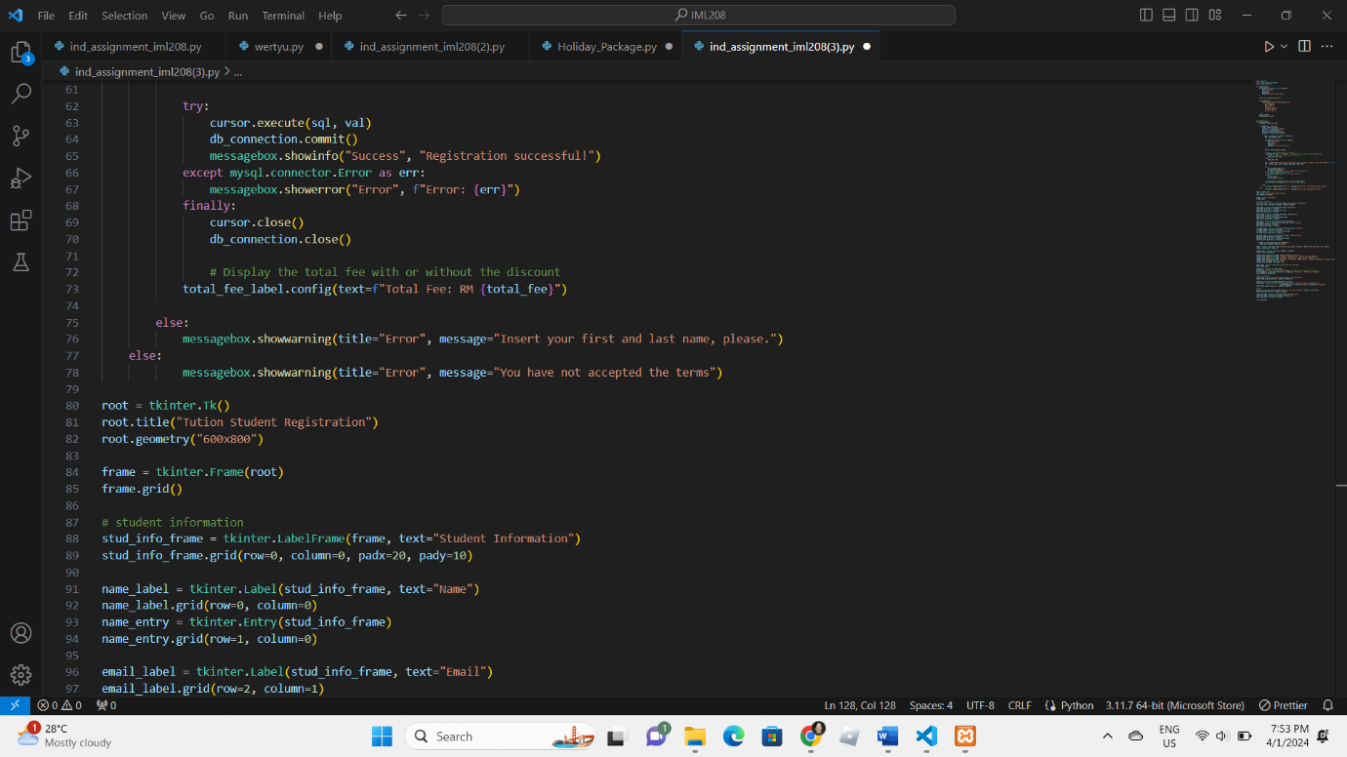**3.0 Code snapshot**

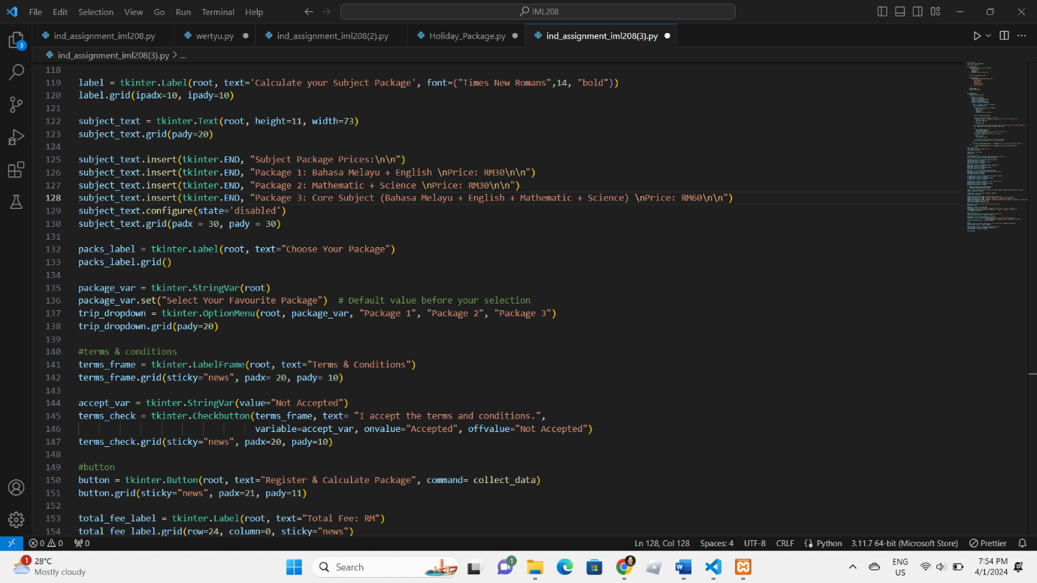

**4.0 GUI snapshot**

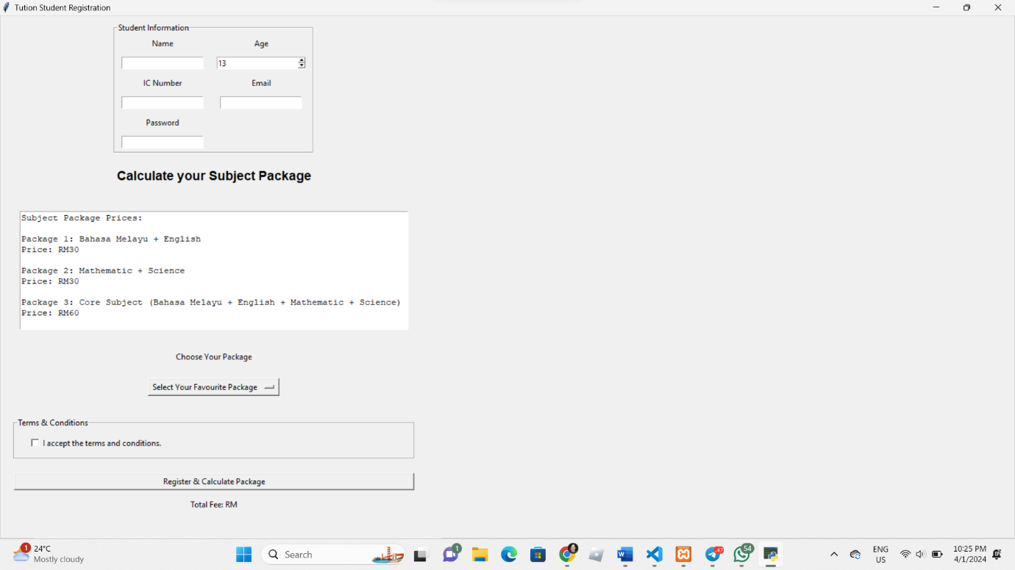

**5.0 Database snapshot**

